

217, Sheikh Rashid Building

P.O Box 56272, Dubai

United Arab Emirates

Tel: +971 4 2973236 / 04 2974007

Email: uae@verbat.com

PROJECT   
PROPOSAL

**MELI**

|  |  |
| --- | --- |
| **Prepared for:** | **Submission Date:**  24 April 2018  **Proposal ID:** SW/24042018/1245/1 |

________________________________________________________________________________________________________________________________  
Conﬁdentiality Notice: This Proposal is conﬁdential and contains proprietary information and intellectual property of Verbanet Technologies LLC. Neither this proposal nor any of the information contained herein may be reproduced or disclosed under any circumstances without the express written permission of Verbanet.

© 2017 by Verbanet Technologies LLC. All rights reserved. Confidential.

_______________________________________________________________________________________________________________________________

Project Contacts

|  |  |
| --- | --- |
| Client Information | |
| Project Name | MELI |
| Client Name |  |
| Client Address |  |
| Phone Number |  |
| Contact Person |  |
| Contact Person Email |  |
| Contact Person Phone Number |  |
| Contact Person Fax Number |  |
| Verbat Information | |
| Contact Person | Ms. Joyce Daniel |
| Contact Person Phone Number | 04 2973236 |
| Contact Person E-Mail | Joyce.daniel@verbat.com |
| Address | PO Box 56272, Dubai |
| Physical Address | Flat 217, Sheik Rasheed Building, Hor Al Anz East, Dubai |
| Project Information | |
| Proposed Technology/Methodology | PHP, Code Ignitor, Android, IOS, JAVA |
| Anticipate Start Date | NA |
| Proposal Valid For | 30 Calendar days from the submission of the proposal |

**Table of Content**

1 Executive Summary 5

1.1 Solution Objective 6

1.1.1 Student Portal 6

1.1.2 Faculty Portal 7

1.1.3 Staff Portal 7

1.1.4 Project Management - Features 9

1.1.5 Inventory Management 10

1.1.6 Request Forms 10

1.2 Advantages of Proposed Solution 12

1.3 Why Verbat 12

1.4 Key Differentiators 13

1.5 Underlying Support Services 14

2 Functional Specification 15

2.1 Web Development 15

2.2 Mobile Development 19

3 Assumptions 21

4 Out of Scope 21

5 Technology Solution 22

5.1 Technical Configuration 22

5.1.1 Development Tools 22

5.1.2 Browser Compatibility for Web Admin 23

5.1.3 Hardware Interface 23

6 Delivery Management 23

6.1 Project Management 23

6.2 Roles and Responsibilities 23

6.3 Phase Delivery Activity summary 25

6.4 Project Implementation plan 25

6.5 Deliverables 25

6.6 Release Planning 26

6.7 Risk and Contingency planning 26

7 Change Management 28

8 Project Effort & Timeline 29

8.1 Effort Estimate 29

8.2 Delivery TimeLine 29

9 Commercial overview 30

10 Miscellaneous 31

10.1 Warranty 31

10.2 Acceptance Criteria 31

10.3 General Terms and Conditions 31

10.4 Assumptions and Dependencies 32

10.5 Source Code & Intellectual Property Rights 33

11 Our Clients 34

# Executive Summary

Muslim English Language Institute (MELI), here after referred to as the “client” is a private institution in the Islamic Republic of Afghanistan. It ranks itself as the premier institute for developing English language skills for the citizens of Afghanistan. The client has contacted Verbat to submit a proposal for the development of its “School Management System”

The proposed features of the application are

* Student portal with mobile application (IOS and Android)
* Faculty Portal with mobile application (IOS + Android)
* Staff Portal with mobile application (IOS + Android)
* Admin Module
* Inventory management
* Asset management
* Project Management
* Performance reports
* Payment gateway
* Biometric interfaces
* Smart TV
* Email & SMS

Application Development is an area where Verbat has in-depth knowledge and expertise. Being the pioneers in Web based and windows based solutions across the major verticals, we are sure to help you enhance your customer engagement to drive differentiation. We bring proven methodologies and processes, global expertise in application development, and a legacy of best practices and ready-to-fit frameworks to expedite the development cycle and reduce the total cost of ownership.

Verbat is pleased to have received the request to submit the proposal and values it as a great opportunity to have a long term & mutually beneficial association with the client. Verbat has gone through the requirement and presents a technical proposal for the requested system. With the focus of delivering value to client, Verbat proposes a managed solution model for this requirement.

## Solution Objective

The client requires a student and Teacher portal app for mobile devices. In the student app portal student should be able to check their overall performance by making charts.

### Student Portal

The **Student Portal** (and Mobile Application) will have the following features

**Student Registration**: Student should have flexibility to apply online or should come to office for their registration

**Student Fees:**  Once the registration is done students should submit fees physically or through online.

**Student Attendance:** Duringadmissions student shall have the option to schedule their classes. Once the Schedule is selected the procedure for attendance is

* A real time view of classes being conducted with the name and photo of the teacher along with class timing on a smart screen monitor
* The students name and picture will also be shown alongside the Teachers picture on the smart screen monitor.
* A biometric device shall be used to capture the student’s attendance. As soon as they are authenticated by the biometric device, it will indicate the status of the attendance of the student on the smart screen monitor

**Student fees and due dates**: Student shall receive notification in their app when fees are due and when they are nearing their cutoff dates for fee payment

**Student Transfer**: Student shall be able to make transfer request to another campus. Their request shall be approved by the Academic Director

**Student award and comments/ note**: The system shall maintain student’s awards, comment and notes made during the length of the course

**Student Examination**: There shall be two types of exams

* Written
* Verbal

Both of the exams shall be online.

**Student Result**: Once the exam is completed,

* The students shall receive their marks.
* Students shall also be able to print their exam pass certificates
* The student certificate shall contain the digital signature of the examiner
* If students fail with marks close to the pass mark, then they shall be admitted to repeat the exam
* If a student misses an exam then notification shall go for the next schedule. Students shall provide reason for not attending the exam and it shall be approved by the academic director.
* Biometric identification shall be used to verify students and shall show real time attendance of a student attending the exam.

**Admission withdrawal Letter**: Student shall be able to apply for admission withdrawal.

**Classes**: System shall maintain information about the class.

**Class Subjects**: System shall maintain the information on all subjects associated with a particular class.

**Class Fees:** System shall maintain the fees associated with classes.

### Faculty Portal

The faculty portal provides notifications to the teacher about their classes

They shall also have

* Class assignment record
* Leave request
* Comment box
* Graph/chart of their performance

**Academic Director**: The system shall allow the

* Addition of new time table,
* Updating of time tables
* Viewing time table of all the classes.

**Event calendar**: System shall maintain upcoming events and their schedules

### Staff Portal

**Human Resources**

Recruitment Bio data includes

* Personal Information
* Salary defined by steps and grades
* Tax
* Security

**Status of Employee**

* Active
* Inactive (reason)
  + Resigned
  + Terminated
  + Blacklisted
  + Laid off

**Performance Appraisal**

* Performance Appraisal Period wise
* Increment /Promotion
* Employee with “X” performance rating
* Appraisal not receive
* Performance Position Summary
* Confirmation Due
* First Increment Due

**Transfer of Employee**

* Teachers
* Staff

Note: Fields associated with employee transfer include

* Current Location
* Location Send

These may also include fields to store privileges. For ex.

* Accommodation
* Travel Expenses

**Manpower Planning:** Shall contain the following information

* Skills
* Separation List
* Job function wise Analysis
* Grade wise Separation
* Employee Eligibility for gratuity
* Experience Status
* Background
* Employee growth Report

**Promotion and Increments**

* Branch wise Assessment
* Employee Stagnation Report
* Increment and promotion Trend
* List of Promoters
* Job function wise Increment
* Grade wise Assessment Summary

**Payroll**

* Attendance
* Payroll Summary
* Meal Charges
* Payroll Employee Slip wise

Note: Tax and Security + Meal shall be deducted from Employee Salary.

**Recruitments**

* Recruitments Requisition Form
* Applicants List :Note that in the applicant list there shall be an option for Pending, Selected and Rejected
* Standard Letters such as interview letter and Rejected Letters.

### Project Management - Features

* Flexibly assign resources at the project level
* View the entire project plan with an easy-to-read chart view
* Identify and view task assignments in an intuitive chart format
* Record project issues down to the task level, and track them with descriptions
* Generate pricing estimates for pre-sale projects from underlying project plan and staffing model
* Track changes to the project plan over time using baseline functionality
* Manually override user cost at the project level
* View pipeline reports, gaining visibility into future enterprise revenue and profit opportunities
* create project-level and date-based budgets
* budget categories to identify different budget items within the total budget amount

### Inventory Management

* Separate categories
* Create and manage multiple stores per employee
* Edit inventory
* Regular updates on out of stock products
* Informative dashboard to get all inventory info at a click of a button
* Map stores by importing valid areas, sections, shelves, categories, etc.
* Update inventory package as data is received from the customer
* Basic and advanced report generating feature to give up to date info on the inventory status
* Feature to export reports on to Excel, PDF and other external file formats
* File barcode can be mapped against each ‘SKU’ and many more…
* Item classification into divisions, sections, departments.
* Item detail with multiple attribute and categories.
* View reports with images
* Sample management
* Dead on arrival
* Real time view of inventory levels with in depth inventory analysis
* Track floor stock, warehouse stock
* Track goods movement through various stages at barcode and package level
* Inventory valuation on FIFO, LIFO, Average and Last purchase.
* Inventory movement (opening, purchase, sales, consumption, closing) at quantity and value
* Road permit tracking for all inwards and outward movement of goods
* Inter-stock point transfer and reconciliation entries
* Negative stock alert on each inventory movement: instead it should be freeze

### Request Forms

* Leave Request
* Increment Salary Request
* Over time Request
* Promotion /Demotion Request
* Vacancy Request
* Resignation request
* Transfer Request
* Taxi form
* Request form
* Purchase Request Form
* Item request Form
* Request for Daily wages
* Employee Complain Request
* Student Complain Request
* Request for Fuel
* Request for transfer for staff /students
* Request for IT ticketing
* Maintenances Request

The scope of the system includes

* Study, Design, Development & implementation of the client’s School Management System
* QA & UAT
* Application documentation (Wireframes, Requirements, Specifications & Test Cases)

.

Verbat’s Solution architects have conducted a thorough research on the requirements and have come to the conclusion that our proposed solution, which is detailed further in this document, will meet the requirements put forth by the client. And the proposed solution will be delivered in a phased approach as per Verbat‘s managed solution model.

**Strong and Scalable platform:** The platform proposed will be strong and scalable enough to accommodate future enhancements such as scheduling, auditing & logging, push notifications etc.

**Accelerated solution:** The framework would act as a solution accelerator. It would provide the basic building blocks which could be reused in future for building new components and features as part of enhancements

**High performance:** The light weight framework used consumes fewer system resources thereby making the application perform faster

* System shall be available 24/7
* System shall be performant without any lags or delays
* System should be accessible by up to 15 people at a time
* System Shall be able to store up to 10,000 soldier details at a time

**Security:** The application will be developed considering various aspects of security.

* Only authorized personnel shall have access to the system

## Advantages of Proposed Solution



01

Agile development offering reliable, scalable and secure solution

02

Smooth transition and quicker completion of processes

03

User friendly interfaces enabling easy navigation between screens

## Why Verbat

Globally Accredited

Software Consultation Partner

Spearheaded by a   
team of Technology and   
Management Leaders



Over 16+ years of customer experience with Global   
Corporations

Service in Banking, Retail, Logistics, Construction & Contracting, Fashion, Manufacturing, Hospitality, Automotive, Healthcare and Government sectors

IT Strategy, Application Development and Maintenance, Testing Services, Information Management and Digital Marketing efforts



## Key Differentiators

Delivered digital transformation expertise to global customers for over a decade by following industry best practices to maximize ROI for client

Keen technology intelligence combined with aggressive market research to deliver solutions that achieve results with measurable value

Enable access to global consulting expertise with strong local market and business knowledge

Commercial Model that is customizable for your business needs

Reuse of code libraries for Rapid Application Development

1,000,000 plus man-hours of expertise in technology frameworks spanning Microsoft, Open Source, mobility platforms and other proprietary IT technology

Partners top technology vendors to bring in the latest and best services in integration, collaboration, and development

Commercial Model that is customizable for your business needs

Proven Methodologies & Processes

Investment in R & D

Strong Local Presence

Flexible commercial Models

Technology Associations

Code Repository

Software Development Experience

Offshore Development Centre

## Underlying Support Services

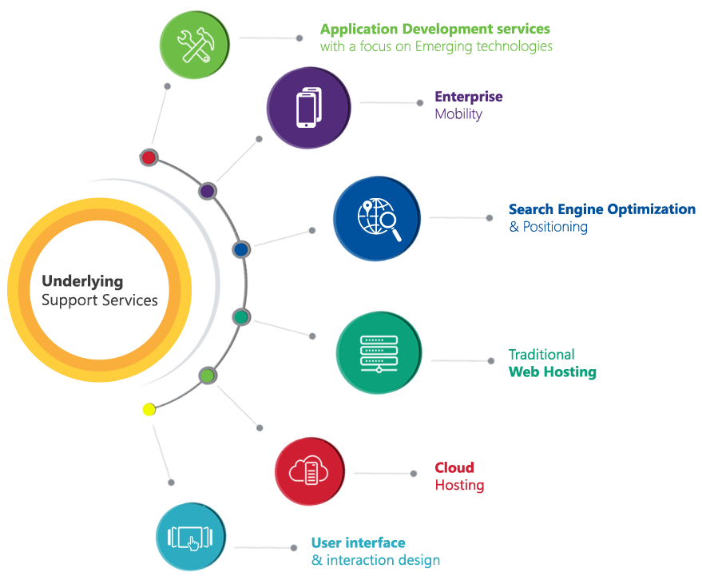

# Functional Specification

The Features that have been considered for development have been listed below

## Web Development

|  |
| --- |
| **Development** |
| **Student Portal** |
| Student Registration |
| Student Fees - Pay online |
| Student fee notification |
| Student transfer |
| Student awards |
| Student Exam online Written |
| Student Exam online Verbal |
| Student Exam results |
| Exam Results Certificates |
| Exam Results: Digital signature of examiner |
| Exam repeat for failed students |
| Reason for missing exam and Exam approval |
| Admission Withdrawal |
| **Attendance management** |
| Student ID cards |
| Biometric Attendance System |
| Student Attendance Metrics |
| SMART TV for classes (for students and teachers) |
| Feedback |
| **Faculty Portal** |
| Class management |
| Subject management |
| Class Fee management |
| Class notifications |
| Class assignment record |
| Leave request |
| Comment box |
| Performance chart |
| **Admin Module (Academic Director)** |
| Campus management |
| Exam Management |
| Digital signature management |
| Faculty management |
| Timetable management |
| Fee schedule |
| Fess management |
| Attendance management (faculty + Students + Staff) |
| Calendar management |
| **Recruitment Subsystem : (Staff portal)** |
| Personal Information |
| Salary by steps and grades (??) |
| Tax |
| Security |
| Employee Status |
| **Performance appraisal : (Staff portal)** |
| Performance Appraisal Period wise |
| Increment /Promotion |
| Employee with “X” performance rating |
| Appraisal not receive |
| Performance Position Summary |
| Confirmation Due |
| First Increment Du |
| **Employee Transfer (current + future location) : (Staff portal)** |
| Teachers |
| Staff |
| Privileges: Accommodation + Travel Expenses |
| **Manpower Planning : (Staff Portal)** |
| Skills |
| Separation List |
| Job function wise Analysis |
| Grade wise Separation |
| Employee Eligibility for gratuity |
| Experience Status |
| Background |
| Employee growth Report |
| **Promotions and increment : (Staff Portal)** |
| Branch wise Assessment |
| Employee Stagnation Report |
| Increment and promotion Trend |
| List of Promoters |
| Job function wise Increment |
| Grade wise Assessment Summary |
| **Payroll : (Staff Portal)** |
| Attendance |
| Payroll Summary |
| Meal Charges |
| Payroll Employee Slip wise |
| Note: tax and Security +Meal should be deducted from Employee Salary. |
| **Recruitment : (Staff Portal)** |
| Recruitments Requisition Form |
| Applicants List |
| Note: in the Applicant list there should be option for Pending, Selected, Rejected |
| Standard Letters such as interview letter and Rejected Letters. |
| **Dashboards** |
| Student Dashboard |
| Teacher dashboard |
| **Request Forms** |
| Leave Request |
| Increment Salary Request |
| Over time Request |
| Promotion /Demotion Request |
| Vacancy Request |
| Resignation request |
| Transfer Request |
| Taxi form |
| Purchase Request Form |
| Item request Form |
| Request for Daily wages |
| Employee Complain Request |
| Student Complain Request |
| Request for Fuel |
| Request for transfer for staff /students |
| Request for IT ticketing |
| Maintenances Request |
| **Inventory Management** |
| Separate categories |
| Create and manage multiple stores per employee |
| Edit inventory |
| Regular updates on out of stock products |
| Informative dashboard to get all inventory info at a click of a button |
| Map stores by importing valid areas, sections, shelves, categories, etc. |
| Update inventory package as data is received from the customer |
| Basic and advanced report generating feature to give up to date info on the inventory status |
| Feature to export reports on to Excel, PDF and other external file formats |
| File barcode can be mapped against each ‘SKU’ and many more… |
| Item classification into divisions, sections, departments. |
| Item detail with multiple attribute and categories. |
| View reports with images |
| Sample management |
| Dead on arrival (defective items received) |
| Real time view of inventory levels with in depth inventory analysis |
| Track floor stock, warehouse stock |
| Track goods movement through various stages at barcode and package level |
| Inventory valuation on FIFO, LIFO, Average and Last purchase. |
| Inventory movement (opening, purchase, sales, consumption, closing) at quantity and value |
| Road permit tracking for all inwards and outward movement of goods |
| Inter-stock point transfer and reconciliation entries |
| Negative stock alert on each inventory movement: instead it should be freeze |
| **Project Management** |
| Flexibly assign resources at the project level |
| View the entire project plan with an easy-to-read chart view |
| Identify and view task assignments in an intuitive chart format |
| Record project issues down to the task level, and track them with descriptions |
| Generate pricing estimates for pre-sale projects from underlying project plan and staffing model |
| Track changes to the project plan over time using baseline functionality |
| Manually override user cost at the project level |
| View pipeline reports, gaining visibility into future enterprise revenue and profit opportunities |
| create project-level and date-based budgets |
| budget categories to identify different budget items within the total budget amount |
| **Asset Management** |
| Asset Register with options for automatic depreciation (straight line and reducing balance) |
| **Reporting** |
| Performance charts |
| HR management reports |
| **System Features** |
| School ID Setup |
| Biometric Setup |
| Payment gateway |
| Email |
| SMS |
| Auditing & logging |
| Exception handling |
| Mobile API |

## Mobile Development

|  |
| --- |
| **Prototype design** |
| **Student Portal** |
| Login |
| Student Registration |
| Student Fees - Pay online |
| Student fee notification |
| Student transfer |
| Student awards |
| Student Exam online Written |
| Student Exam online Verbal |
| Student Exam results |
| Exam Results Certificates |
| Exam Results: Digital signature of examiner |
| Exam repeat for failed students |
| Reason for missing exam and Exam approval |
| Admission Withdrawal |
| **Attendance management** |
| Student ID cards |
| Biometric Attendance System |
| Student Attendance Metrics |
| Feedback |
| **Faculty Portal** |
| Login |
| Class management |
| Subject management |
| Class Fee management |
| Class notifications |
| Class assignment record |
| Leave request |
| Comment box |
| Performance chart |
| **Staff Portal** |
| Login |
| **Recruitment** |
| Personal Information |
| Salary by steps and grades (??) |
| Tax |
| Security |
| Employee Status |
| **Performance appraisal** |
| Performance Appraisal Period wise |
| Increment /Promotion |
| Employee with “X” performance rating |
| Appraisal not receive |
| Performance Position Summary |
| Confirmation Due |
| First Increment Du |
| **Employee Transfer (current + future location)** |
| Teachers |
| Staff |
| Privileges: Accommodation + Travel Expenses |
| **Manpower Planning** |
| Skills |
| Separation List |
| Job function wise Analysis |
| Grade wise Separation |
| Employee Eligibility for gratuity |
| Experience Status |
| Background |
| Employee growth Report |
| **Promotions and increment** |
| Branch wise Assessment |
| Employee Stagnation Report |
| Increment and promotion Trend |
| List of Promoters |
| Job function wise Increment |
| Grade wise Assessment Summary |
| **Payroll** |
| Attendance |
| Payroll Summary |
| Meal Charges |
| Payroll Employee Slip wise |
| Note: tax and Security +Meal should be deducted from Employee Salary. |
| **Recruitment** |
| Recruitments Requisition Form |
| Applicants List |
| Note: in the Applicant list there should be option for Pending, Selected, Rejected |
| Standard Letters such as interview letter and Rejected Letters. |

# Assumptions

The project solution and technology is created from the initial understanding of the requirement shared with Verbat through mails and meetings. The proposed solution is based on the following assumptions;

* Color theme shall be provided by the client
* The client shall provide the branding guidelines
* Client shall provide licensed images and logos in specified size & format
* Client shall provide biometric devices, Identity card scanner, Smart TV as well as the software interfaces (including SDK, libraries or API) to access these devices
* Client shall provide payment gateway, SMS gateway, Email and SSL were required

# Out of Scope

With the ever evolving digital market, the requirement needs should be clear to both the parties involved, hence the importance of mentioning the out of scope details of the project. Following are considered to be out of scope while creating this proposal.

* Purchase of images, fonts
* Adding new features to the application other than mentioned in this proposal
* Any language other than English
* Manual data entry
* Database migration
* Content writing
* Hosting Infrastructure
* Annual Maintenance Contract ( Bug fixing, debugging, enhancements, develop new modules)
* Physical deployment at client’s site

# Technology Solution

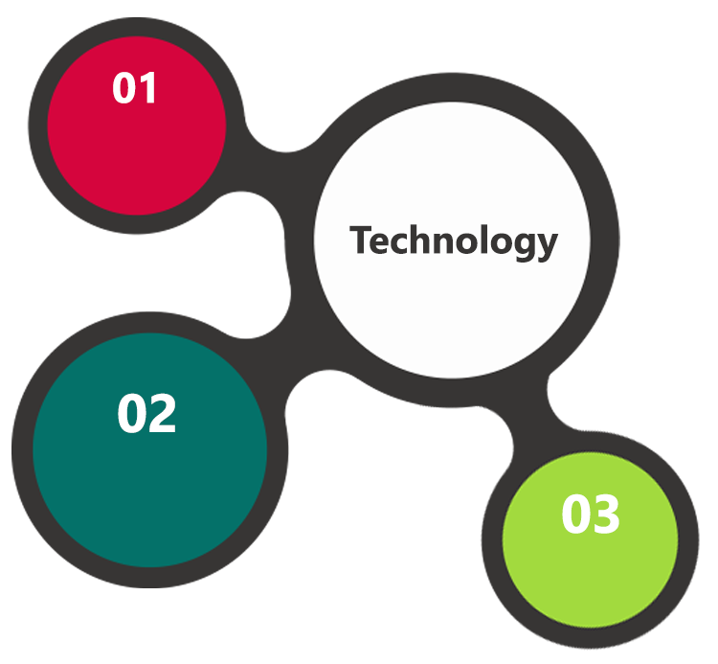

IOS / Android  
Xcode, Java,

PHP

MySql  
Linux  
Web Services

AJAX  
JavaScript  
JSON

.

## Technical Configuration

### Development Tools

* Java, Cocoa, PHP, code Ignitor
* Mysql
* Web services
* Android / IOS

### Browser Compatibility for Web Admin

* Chrome 56.0
* Firefox 51.0
* Internet Explorer 11

### Hardware Interface

The application is reliant on hardware interfaces to provide a seamless automated user experience.

* Computer with Windows 8 or 10 OS
* IOS Mobile device

# Delivery Management

## Project Management

The Verbat development center strictly follows industry standards on quality. The project management is process governed by the Verbat Quality Management system and is put to verification through internal audit programs that happen from time to time.

Verbat will dedicate a project manager for the proposed implementation. Verbat proposes Client to identify one project manager who will be driving activities to be undertaken by Client to be the single point of contact for Verbat.

## Roles and Responsibilities

Verbat will assign a dedicated Project Manager/Project Lead to lead the project, who will be the first point contact for Client. He/she will be responsible for planning and managing the various activities within the project. He/she will work closely with Client Project Manager, to give periodic status updates and ensure high level of visibility and comfort on the progress of the project.

The Project Manager/Project Lead will lead the co-ordination between Verbat and Client, thus enabling smooth transitioning of Client requirements to the Verbat’s offshore delivery team, and provide visibility as well as comfort on the progress of the services to Client.

He/she will have periodic meetings with Verbat’s Senior Management, thus ensuring Verbat’s Management commitment and focus on Client initiatives.

*Note: detailed qualification and experience of the persons involved in the project will be shared be finalizing the project on request*

## Phase Delivery Activity summary

|  |  |
| --- | --- |
| Activities | Description |
| Detailed requirement Analysis | Verbat team to conduct detailed study of requirement for the phase. If clarification is required, team will reach out to Client for more information and/or time for discussions. |
| Software Requirement Specification document (SRS) | Once the requirement analysis is completed, Verbat team will submit the SRS document for approval |
| UI/UX Design, Prototyping | Based on the SRS, Verbat UX/UI team will work on the UI/UX of the screens and submit a prototype for approval |
| Functional Specification Document (FS) | Once the Prototype. UI/UX is approved, Verbat shall submit an FS document for approval. |
| Development | Actual system development starts based on the FS. This involves detailed design and software development of Web Admin, API & iOS and Android mobile app. |
| Testing | Test Planning, test plan creations, internal, integration testing and user acceptance testing. |
| Deployment | Deploying the latest built in the Verbat Test Server. |

## Project Implementation plan

Verbat will be providing the solution in a phased approach which ensures minimum viable solution for quick wins with core focus on the long term business objective and outcome. Once the implementation of phase 1 is over, Verbat will initiate the application maintenance process which continues to extend after the implementation of successive phases.

## Deliverables

* Software Requirement Specification Document (SRS)
* Wire Frames for Key Screens
* Fully Developed & Tested Application
* Fully commented source code
* User Manual (English)

## Release Planning

* Client will be informed about the release date and time through email.
* Client performs the UAT

## Risk and Contingency planning

Verbat has identified various risk factors associated with this assignment and understands the impact of these risk factors on the project schedules. The objective of this section is to highlight for both Verbat and client, the risk factors, to analyze the impact of the risks on project execution, and to propose strategies to control and reduce the impact of the risk factors.

These various risks, which could arise during the project, are tabulated below along with mitigation implementation.

| Type of risk | Impact | Risk Mitigation | Risk Handling |
| --- | --- | --- | --- |
| Scope Creep | H | Functions and features will be detailed in system requirement documents and will go through client approval. Once this document is approved, any change to requirement will go through change management review for possible impact assessment. | Proper change management procedure will be implemented. |
| Delay in customer feedback | H | The plan is prepared with enough lead-time for customer reviews and approvals.  The customer is indicated with the dates when the document is expected after review and approval. | The request for feedback will be escalated if not attended at the right time so that the schedules are not affected. Deemed acceptance criterion is set up front and will be followed. |
| Non-availability of necessary software’s, frameworks, database instances and infrastructure at client’s hosting environment(If hosting support is provided by Verbat) | M | Client will be informed in advance on these requirements. | Possible impact to schedule. |
| Manpower attrition | L | All efforts would be made to ensure process dependence rather than being person dependent. As a risk mitigation plan Verbat will train backups. | A new person will be identified as early as possible, provided the required project-specific training and mentored by the senior members of the team to minimise impact of attrition on the project. |

*H-High, M-Medium, L-Low, NA-Not Applicable*

# Change Management

Any addition which comes out of the project scope, upon and after the launch of the tool will be considered as change management. Verbat recommends the following change management procedure for the same.

* Any change which comes out of the project scope, which was discussed, documented, and mutually approved by both the parties in the requirement stage, will be carried out only through raising a change request.
* Change request will be studied and an impact analysis on the existing work flow will be performed.
* On finalizing the impact, effort estimation for the change will be calculated and raised as additional requirement.
* Verbat will initiate the change request only after getting a formal approval from the client for the additional changes raised.
* Any change from the scope will be charged at **AED 1200 per man day effort** and approval from the clients will be availed before commencing on any change management.

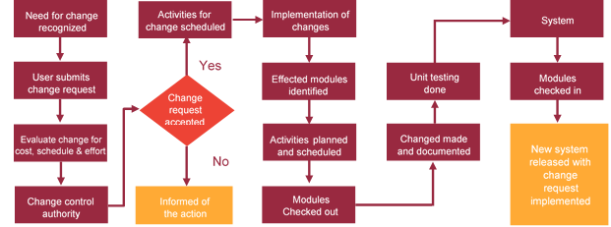

# Project Effort & Timeline

## Delivery TimeLine

|  |  |  |
| --- | --- | --- |
| **Activity** |  | **Delivery Days** |
| Web application development |  | 160 |
| Mobile application development |  | 109 |

# Commercial overview

|  |  |  |
| --- | --- | --- |
| **Description** | | **Cost (USD)** |
| Web application | USD XXX,XX.00 | |
| Mobile Application |  | |
| **Total** | | **$ X,XXXX.XX** |

# Miscellaneous

## Warranty

Verbat shall provide a bug ﬁx warranty at no additional cost for 30 days from the date of acceptance of the project, for correction of any errors in the developed application that may be attributed to Verbat.

However, this does not cover modifications by Client, or use of the application on an environment other than the proposed environment, or other circumstances outside Verbat’s reasonable control. In such a case Verbat reserves the right to charge for its services.

All error corrections will be executed at Verbat India office. In the event of any need for on-site work, all expenses incurred for such trips will be payable to Verbat by Client.

## Acceptance Criteria

* UAT sign off should happen within 14 Days from the release of each module/ Phase and the acceptance confirmation needs to be mailed to Verbat failing which Verbat will consider the project as approved by the client.
* Any comments or reason for rejection need to be documented and the same needs to be sent as an email from the official mail id of client to Verbat.

## General Terms and Conditions

* Offer Valid for 30 calendar days from the date of submission of the Proposal
* An average of 20 working days are assumed in a month
* This proposal and all technical/ functional specifications have been derived or concluded from the data shared via email / information's transferred during the initial requirement analysis meetings and conversations. Verbat reserves the right to amend the terms of this proposal, should the SOW terms, functional features and functionalities change during the course of the project
* The applications will be built as per the specifications agreed mutually. Any changes will be executed through a deﬁned change management process between both parties
* All Source Code and other project artefacts would adhere to the Verbat document templates and internal coding standards
* Acceptance criteria shall be based on the clauses which were mutually discussed between Verbat and client at the Requirement Analysis phase and the same will be documented and approved by both parties through official emails
* Final deployment to production server pursuant to completion of all payments

## Assumptions and Dependencies

* During the requirement gathering phase, authorized personnel from the Client’s side is expected to be available for discussion and finalizing the HLD (High Level Design), before development commences.
* Type of reports and formats, if under the scope of the project, needs to be specified by Client before project sign off.
* Workflows need to be specified/ confirmed by client before project signoff.
* All queries regarding the client requirement and any queries which may hinder the project advancement at any stage should be answered by the client within 24 hours from the time of initiation, failing which the time delay will get added to the actual effort which was estimated.
* Verbat assumes that all sign-offs from Client will be provided within agreed and specified timeframe.
* Client will provide all the necessary contents, both text and image, before starting the project in the format suggested by Verbat (if any).
* The client should provide the relevant information and data well in time for the execution of a related activity. Non- availability of this information or data may lead to an interruption of work which may result in a delay in delivery as well as additional costs to the client.

## Source Code & Intellectual Property Rights

* Upon completion of the Project and 100% completion of the payment, client will have access to the source code except for propriety codes, developer tools and third party application / modules like Microsoft Dynamics Products, Share Point LMS etc.
* The solution offered will be the intellectual property of the client and will be made available to the client on an “unlimited license” basis.
* Modifications by third party/person: No person or organization, other than Verbat or any person authorized by Verbat in writing, has any permission to modify/change the software Solution to be eligible to get continued support from Verbat as per the support terms defined under this document.
* Liabilities/Damages: Verbat accepts no liability or damages of any kind arising out of use or non-use of the software delivered. The responsibility of testing of software lies with Client.

# Our Clients

**UAE University**

Education

Transportation

**Canada Cartage**

Construction

Services

Finance

We look forward to hearing from you soon and hope that you will give us the privilege to work with you in meeting your business goals. Thank you.

Thank You



©   
1999 - 2017. All Rights Reserved   
Verbanet Technologies LLC  
www.verbat.com